**CART Risk Transformation Master Plan Change Management Documentation**

**ID: 001**

* **Date:** July 27 2015
* **Sub-workstream:** Risk Gov. & Org.
* **Initiator:** Oliver Wyman
* **Description:** Reorganized structure of “Design detailed operating model and implementation plans for Risk type / function” by combining by Risk type / function and adding “Op Risk” work into scope
* 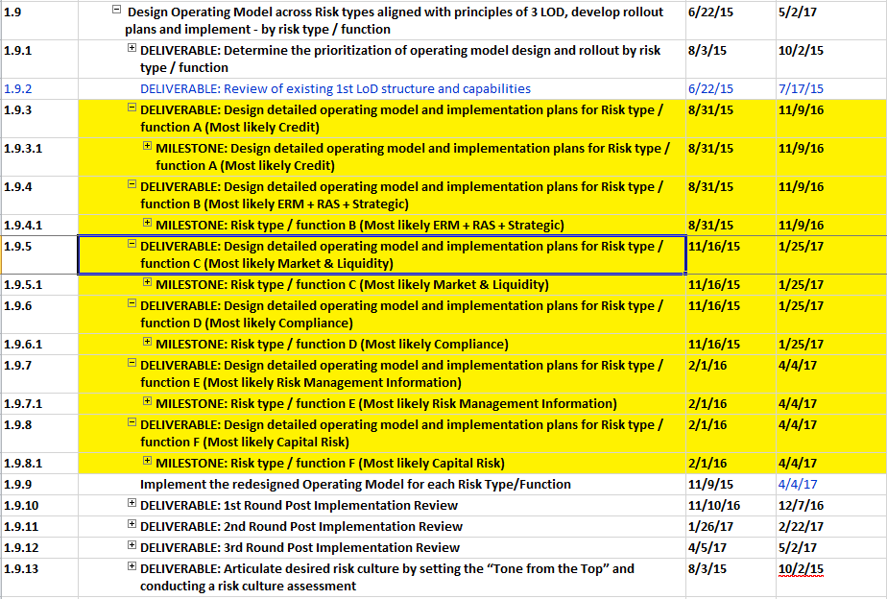**Original View:**
* **Updated View:**

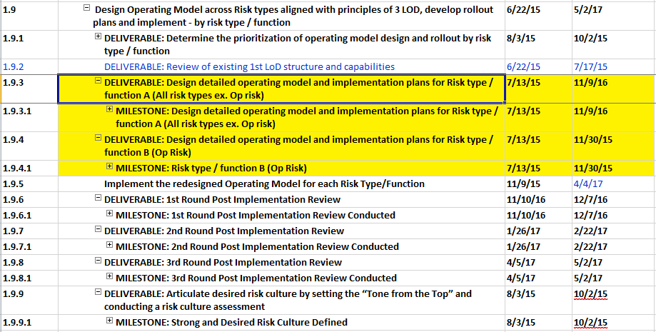

2. Risk ID: Whether to present the results or approved

Simplifying the structure

Instead of having five which is more difficult to track, this view is more concise and goal oriented. Allows for more accurate tracking for more progress in the task line

3. Gov. and Org. change of date

|  |  |  |  |  |
| --- | --- | --- | --- | --- |
| WBS | Task Name | Start | Finish | Duration |
| **1.9.5.4** | **DELIVERABLE: Articulate desired risk culture by setting the “Tone from the Top” and conducting a risk culture assessment** | **2/1/16** | **4/1/16** | **45d** |
| **1.9.5.4.1** | **MILESTONE: Strong and Desired Risk Culture Defined** | **2/1/16** | **4/1/16** | **45d** |
| 1.9.5.4.1.1 | Determine the survey population and tailor survey as needed (1 week) | 2/1/16 | 2/5/16 | 5d |
| 1.9.5.4.1.2 | Deploy culture survey and collect responses (2-3 week) | 2/1/16 | 2/19/16 | 15d |
| 1.9.5.4.1.3 | Aggregate and analyze survey results (2-3 weeks) | 2/22/16 | 3/11/16 | 15d |
| 1.9.5.4.1.4 | Conduct 3-4 targeted focus groups or workshops to refine and validate the insights (1-2 weeks) - goes in parallel with 3. | 2/29/16 | 3/18/16 | 15d |
| 1.9.5.4.1.5 | Review findings, document current state risk culture and priritize focus areas (1 week) | 3/21/16 | 4/1/16 | 10d |
| 1.9.5.4.1.6 | MILESTONE: Strong and Desired Risk Culture Defined | 4/1/16 | 4/1/16 | 0d |

4. Risk ID

**Change 1**

Original View:

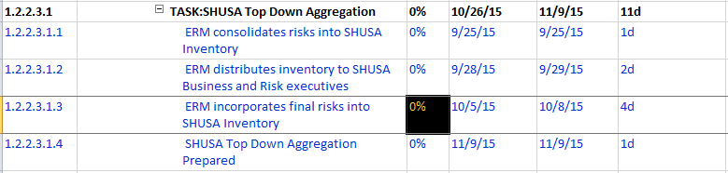

Proposed View: copy/paste from current plan

**Change 2**

Task dates reflect real work dates while milestone reflects presentation date

5. Risk Gov. and Org.

Develop sub-items under Enhance top of the house risk policies and change dates highlighted in yellow

|  |  |  |  |  |  |  |
| --- | --- | --- | --- | --- | --- | --- |
| WBS | Task Name | Entity | Start | Finish | Duration | % Complete |
| **1.6** | **Enhance top of the house risk policies with clear articulation of roles and responsibilities across the Three Lines of Defense (3 LOD)** |  | **7/13/15** | **1/8/16** | **130d** | **0%** |
| 1.6.1 | DELIVERABLE: Credit risk policies and roles and responsibilities |  |  |  |  | 0% |
| 1.6.2 | DELIVERABLE: ERM policies and roles and responsibilities |  |  |  |  | 0% |
| 1.6.3 | DELIVERABLE: RAS policies and roles and responsibilities |  |  |  |  | 0% |
| 1.6.4 | DELIVERABLE: Strategic policies and roles and responsibilities |  |  |  |  | 0% |
| 1.6.5 | DELIVERABLE: Market policies and roles and responsibilities |  |  |  |  | 0% |
| 1.6.6 | DELIVERABLE: Liquidity policies and roles and responsibilities |  |  |  |  | 0% |
| 1.6.7 | DELIVERABLE: Compliance policies and roles and responsibilities |  |  |  |  | 0% |
| 1.6.8 | DELIVERABLE: Risk Management Information policies and roles and responsibilities |  |  |  |  | 0% |
| 1.6.9 | DELIVERABLE: Capital Risk policies and roles and responsibilities |  |  |  |  | 0% |